

Topic test 1
Name: __________________________________

Chapter 3: Trigonometry

- Time allowed: 45 minutes
- CAS calculators may be used.
- Part A: 5 multiple-choice questions (5 marks)
- Part B: 8 short answer questions (45 marks)
- Part C: 2 analysis questions (19 marks)
Part A
5 multiple-choice questions
1 mark each: 5 marks
Circle the correct answer.
1 Which statement is NOT true?
A sin (180°  x)  sin (x)
B sin (2π  x)  sin (x)
C sin (2π  x)  sin (x)
D sin (x)  sin (x)
E sin (180°  x)  sin (x)

[1 mark]
2 The compass bearing S 20° E has a true bearing of
A 020°
B 160°
C 110°
D 200°
E 250°

[1 mark]

3 Which is the correct statement for the triangle below?
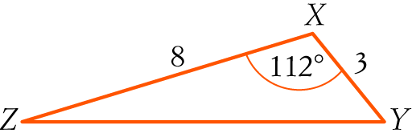
A YZ = 82 + 32 − 8 × 3 × cos (112°)
B YZ2 = 82 + 32 − 8 × 3 × cos (112°)
C YZ2 = 82 + 32 − 2 × 8 × 3 × cos (112°)
D YZ = 82 + 32 − 8 × 3 × sin (112°)
E YZ2 = 82 + 32 − 2 × 8 × 3 × sin (112°)

[1 mark]
4 The area of a sector in a circle of radius 5.1 cm, with an angle of 30° subtended at the centre is:
A 6.8 cm2
B 1.3 cm2
C 390.2 cm2
D 13.6 cm2
E 24.8 cm2

[1 mark]
5 A trapezium has parallel sides a and b. The length of one of its diagonals is c and it makes an angle
of θ as shown. Find an expression for its area.
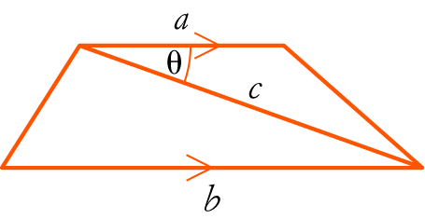
A A = abc sin (θ)
B A = ac sin (θ)
C A = bc sin (θ)
D A = c sin (θ) (a + b)
E A = a sin (θ) (b + c)

[1 mark]

Part B
8 short answer questions
45 marks
Show your working where appropriate.
1 Convert the following to radians, giving exact values.
a 45°

b 300°

c 135°

d 150°

e 400°

[5 marks]
2 Convert the following radians to degrees.
a π

b

c

d 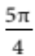

e 3π

[5 marks]

3 Evaluate x correct to one decimal place.
a 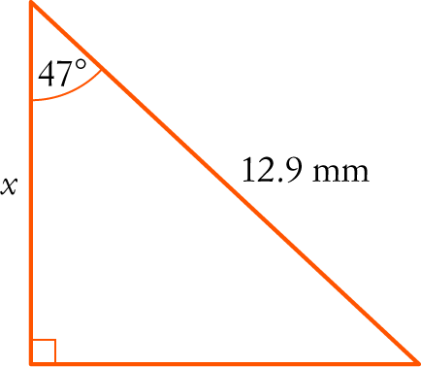
b 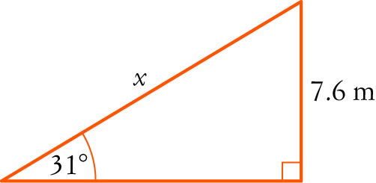
c 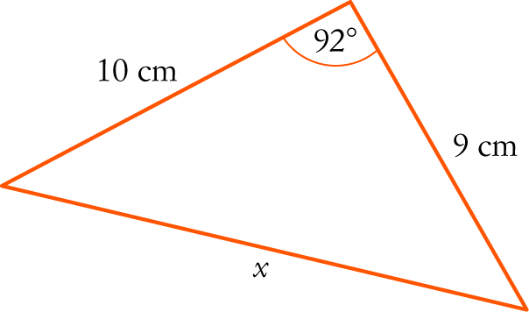
d 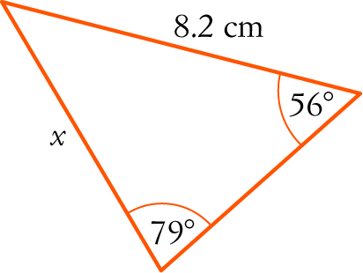
[12 marks]
4 Evaluate θ correct to the nearest degree.
a 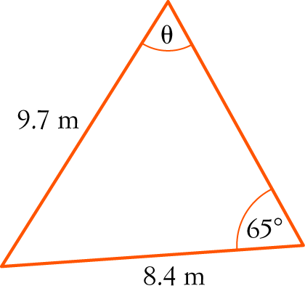
b 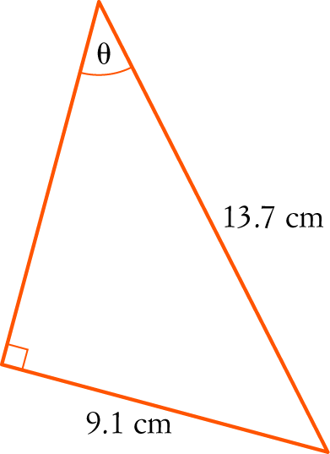

c 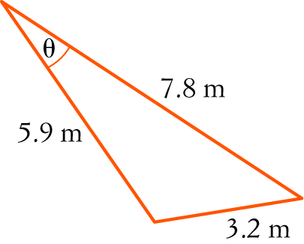
[9 marks]
5 The circumference of a circle is 10 m. Find the length of an arc that is cut off by an angle of subtended at the centre of the circle, correct to two decimal places.

[4 marks]
6 A road has a gradient of . Find its angle of inclination, correct to one decimal place.

[2 marks]
7 A train leaves Cityview and travels on a bearing of 104° for 137 km. It then changes to another track and travels for 78 km on a bearing of 038° to Harbourtown. What is the straight-line distance between Cityview and Harbourtown?

[5 marks]

8 The angle of elevation up to the top of a tree from a point 12.7 m out from its base is 18°. Find the height of the tree correct to one decimal place.

[3 mark]
Part C
2 analysis questions
19 marks
Show your working where appropriate.
1 A garden bed is in the shape of a sector of a circle with radius 12 m and the angle at the centre is 30°.
a Find the area of the garden bed, correct to the nearest m2.

b Fertiliser is needed to fill the garden bed to a depth of 20 cm. What volume of fertiliser is needed?

c A concrete edge is to be built around the outside of the garden bed. It costs $20.50 per linear metre to build this edging. How much will the edging cost in total?

[9 marks]

2 A hot air balloon flying at 950 m/h at a constant altitude of 3000 m is observed to have an angle of elevation of 78°. After 20 minutes, the angle of elevation is 73°. Calculate the angle through which the observer has turned during that time. Answer in degrees and minutes.

[10 marks]
Total marks: 69

Answers
Part A [1 mark each]
1 sin (x) is positive in the 1st and 2nd quadrants.
A sin (180°  x) = sin (x) is true (2nd quadrant)
B sin (2π − x) = −sin (x) is true (4th quadrant)
C sin (2π + x) = sin (x) is true (1st quadrant)
D sin (−x) = sin (x) is not true (4th quadrant)
E sin (180° + x) = −sin (x) is true (3rd quadrant)
∴ D [1 mark]
2 S 20° E is an angle of 20° measured from south and turning towards east.
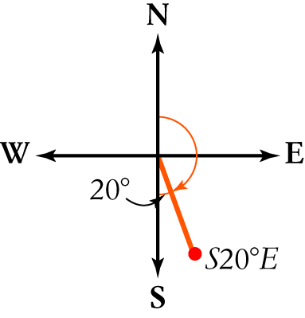
The true bearing measured clockwise from north is 180° − 20° or 160°.
∴ B [1 mark]
3 Cosine rule: c2 = a2 + b2 − 2ab cos (C)
Substituting the information gives YZ2 = 82 + 32 − 2 × 8 × 3 × cos (112°)
∴ C [1 mark]
4 The formula uses radians.
30° = radians
A = r2θ
= × 5.12 
≈ 6.8 cm2
∴ A [1 mark]

5 The trapezium is made up of 2 triangles. Since the lines are parallel, θ is in the other triangle
(see diagram).
Using A = ab sin (C) with both triangles:
A = ac sin (θ) + bc sin (θ)
Factorising gives A = c sin (θ) (a + b)
∴ D [1 mark]

Part B
1 To convert to radians, multiply by 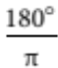 and simplify the fractions.
a 45° × 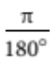  [1 mark]
b 300° × = 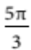 [1 mark]
c 135° × = 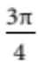 [1 mark]
d 150° × = 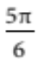 [1 mark]
e 400° × = 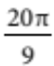 [1 mark]
2 To convert to degrees, multiply by or simply replace π by 180°.
a π = 180° [1 mark]
b 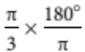 = 60° or = 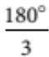= 60° [1 mark]
c 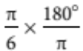 = 30° or 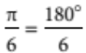 = 30° [1 mark]
d 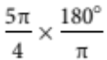 = 225° or 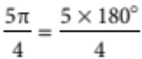 = 225° [1 mark]
e 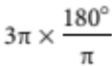 = 540° or 3 × 180° = 540° [1 mark]
3 a cos (47°) = 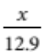 [1 mark]
12.9 cos (47°) = x [1 mark]
8.8 ≈ x
So x ≈ 8.8 mm. [1 mark]
b sin (31°) = 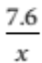 [1 mark]
x = 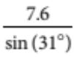 [1 mark]
≈ 14.8
So x ≈ 14.8 m [1 mark]
c Substitute into the cosine rule.
c2 = a2 + b2 − 2ab cos (C)
x2 = 102 + 92 − 2 × 10 × 9 × cos (92°) [1 mark]
= 187.281 9094... [1 mark]
x = 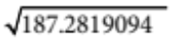
≈ 13.7
So x ≈ 13.7 cm [1 mark]
d Substitute into the sine rule.
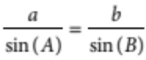
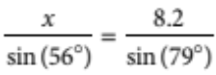
[1 mark]
x = 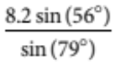 [1 mark]
≈ 6.9
So x ≈ 6.9 cm [1 mark]
4 a Substitute into the sine rule.
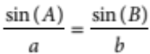
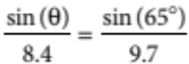 [1 mark]
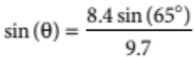 [1 mark]
= 0.784 843 856… [1 mark]
θ ≈ 52° [1 mark]
b 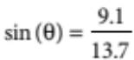 [1 mark]
θ ≈ 42° [1 mark]
c Substitute into the cosine rule.
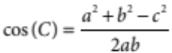
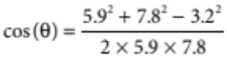 [1 mark]
= 0.927 966 101... [1 mark]
θ ≈ 22° [1 mark]
5 C = 2πr
10 = 2πr [1 mark]
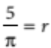 [1 mark]
l = rθ
= 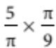 [1 mark]
=
≈ 0.56
So the length of the arc is 0.56 m. [1 mark]
6 Gradient = tan (θ)
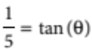 [1 mark]
11.3° ≈ θ
So the angle of inclination is 11.3°. [1 mark]
7 Draw a diagram that shows the information.
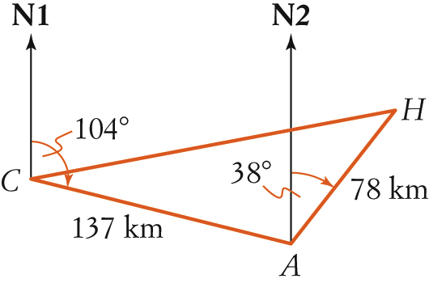 [1 mark]
Find angle CAH.
/CAN2 = 180° − 104° = 76° (C N₁iC N₂)
/CAH = 76° + 38° = 114° [1 mark]
Using the cosine rule:
c2 = a2 + b2 − 2ab cos (C)
CH2 = 1372 + 782 − 2 × 137 × 78 × cos (114°) [1 mark]
= 33 545.775 54… [1 mark]
CH = 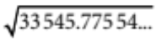
≈ 183
So the distance is 183 km. [1 mark]
8 Draw a diagram to show the information.
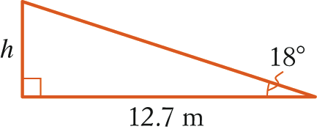 [1 mark]
tan (18°) = 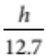 [1 mark]
12.7 tan (18°) = h
4.1 ≈ h
The tree is 4.1 m high. [1 mark]
Part C
1 a 30° = radians [1 mark]
Area of sector:
A = 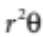
= 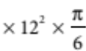 [1 mark]
= 12
≈ 38 m2
So the area of the garden bed is 38 m2. [1 mark]
b 20 cm = 0.2 m
V = Ah
= 12 × 0.2 [1 mark]
≈ 7.5
So the volume of fertiliser is 7.5 m3. [1 mark]
c 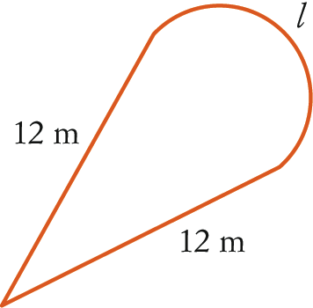
l = rθ
= 12 × [1 mark]
= 2
≈ 6.3
Perimeter of the sector:
P = 12 + 12 + 2 [1 mark]
≈ 30.3
Cost = 30.3 × $20.50 [1 mark]
≈ $620.81
So the cost of the edging is $620.81. [1 mark]
[9 marks]

2 Draw a diagram to show the information.
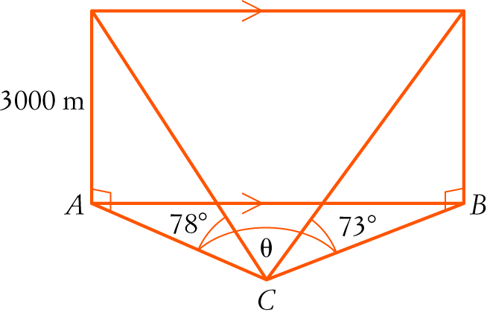 [1 mark]
Find side AC.
tan (78°) = 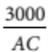
AC = 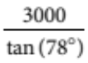 [1 mark]
= 637.669685 [1 mark]
Find side BC.
tan (73°) = 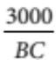
BC = 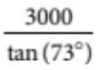 [1 mark]
≈ 917.192 044... [1 mark]
Find side AB.
The balloon travels 950 m in 1 hour, so it travels 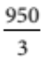 m or 316.6666… m in 20 minutes.
AB is parallel to the path of the balloon, so AB = 316.6666… [2 marks]
Substitute into the cosine rule:
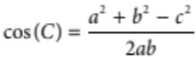
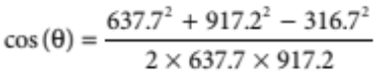 [1 mark]
≈ 0.981 068 274... [1 mark]
θ ≈ 11.2° or 11° 10’ [1 mark]
[10 marks]

